### **A CRM APPLICATION TO ENGINEERING WORKS**

# Project Overview

This project involves developing a **Customer Relationship Management (CRM) application** tailored to the needs of engineering works. The goal is to enhance customer management, streamline project tracking, and improve communication for engineering firms. The CRM will centralize client information, optimize workflow, and ensure timely delivery of projects.

The main aim of the project is:

1. **Manages customer relationships** effectively.
2. **Tracks project progress** from inquiry to completion.
3. **Streamlines operations**, improving productivity and decision-making.

# Objectives

The goal of this project is to create a simple and effective CRM application that helps engineering firms:

**Manage Clients**: Store and organize customer details and interactions.

**Track Projects**: Monitor project progress, deadlines, and tasks.

**Automate Tasks**: Send reminders, follow-ups, and generate reports.

**Make Better Decisions**: Use data and insights to improve work and customer satisfaction.

# Salesforce Key Features and Concepts Utilized

**Contact and Account Management**

* Store detailed customer information, including company data, project history, and contact details.
* Track relationships between clients, contractors, and suppliers.

**Lead and Opportunity Management**

* Capture potential clients and track their journey from inquiry to contract signing.
* Monitor the status of opportunities, forecast revenue, and prioritize high-value projects.

**Task and Activity Tracking**

* Schedule follow-ups, meetings, and project-related tasks.
* Maintain a log of all interactions for transparency and accountability.

**Project Tracking and Collaboration**

* Utilize **Salesforce Chatter** for team collaboration on projects.
* Create workflows and milestones for engineering projects.

**5** **Automation with Workflow Rules and Process Builder**

* Automate tasks like sending email reminders for approvals, updating project status, and generating invoices.
* Use **Flows** for advanced process automation specific to engineering workflows.

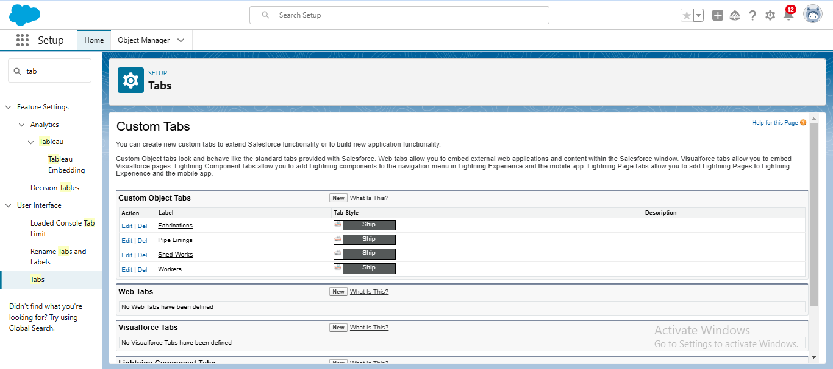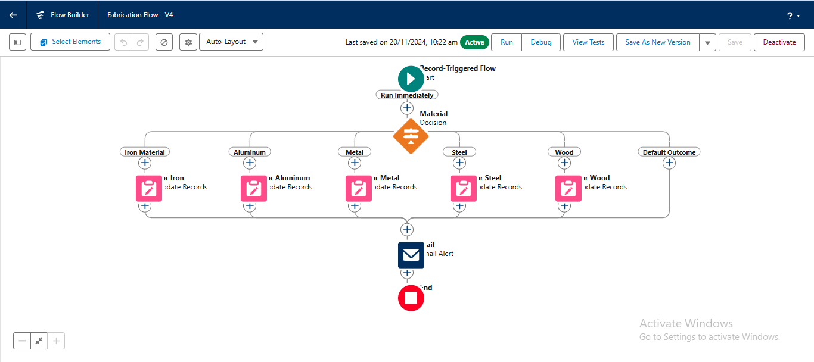

# Detailed Steps to Solution Design

**Understand Needs**

* Talk to users (engineers, managers, sales teams) to know what they need: managing clients, tracking projects, and automating tasks.

**List Key Features**

* Customer management
* Project tracking
* Task automation
* Reports and dashboards

**Plan the System**

* Decide what data to store (clients, projects, tasks).
* Define user roles (Admin, Manager, Engineer).

**Use Salesforce Tools**

* Standard tools like Leads, Accounts, and Tasks for basic needs.
* Custom objects for unique needs (e.g., blueprints, project stages).

**Create a Prototype**

* Set up a basic system with sample data.
* Test features like project updates and automated reminders.

**Integrate Tools**

* Connect CRM with existing tools (e.g., design software, ERP).

**Test the System**

* Check if all features work as planned.
* Get user feedback for improvements.

**Launch and Train**

* Roll out the system in phases.
* Train users on how to use it.

**Monitor and Improve**

* Fix issues and add new features based on user feedback.

# Testing and Validation

**Feature Testing**

* Check if key features like customer management, project tracking, and task automation work correctly.

**Integration Testing**

* Ensure the CRM connects and shares data smoothly with other tools (e.g., CAD, ERP).

**User Testing**

* Let actual users try the system and give feedback on its ease of use and functionality.

**Performance Testing**

* Test how the system performs with multiple users and large amounts of data.

**Security Testing**

* Verify that data is protected, and only authorized users can access sensitive information.

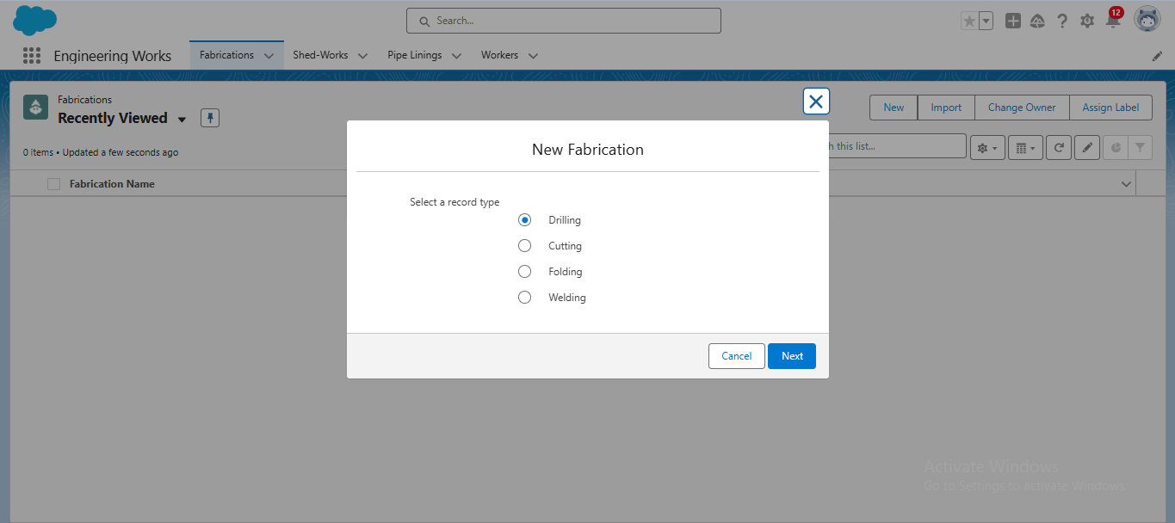

# Key Scenarios Addressed by Salesforce in the Implementation Project

**Customer Management**

* Centralize customer information, including contact details, project history, and interactions, to ensure efficient communication and relationship building.

**Lead and Opportunity Tracking**

* Manage leads from inquiry to conversion and track opportunities for new projects, ensuring a streamlined sales pipeline.

**Project Tracking and Collaboration**

* Monitor project progress with milestones, deadlines, and deliverables while enabling team collaboration through Salesforce Chatter.

**Task Automation**

* Automate repetitive tasks such as follow-ups, reminders, and status updates using Workflow Rules and Process Builder.

**Custom Reporting and Dashboards**

* Generate real-time reports and dashboards to provide insights into project performance, customer trends, and business metrics.

**Integration with Engineering Tools**

* Connect Salesforce with external tools like ERP systems, CAD software, or document management systems for seamless data flow and enhanced productivity.

# Conclusion

A Salesforce-based CRM for engineering works helps manage customers, track projects, and automate tasks in one place. It makes work more organized, saves time, and improves customer satisfaction. With easy access to data, clear reports, and seamless integration with other tools, this solution supports better decision-making and helps engineering firms work more efficiently and grow their business.